Cairo University Faculty of Computers and Information



**Software Engineering II**

**Daily scrum meeting template**

**2019**

**Project Team**

|  |  |  |  |
| --- | --- | --- | --- |
| **ID** | **Name** | **Email** | **Mobile** |
|  | 1st name is team leader |  |  |
|  |  |  |  |
|  |  |  |  |
|  |  |  |  |
|  |  |  |  |
|  |  |  |  |

Title page has no header or footer.

Docs must be supplied as pdf –files re-named as requested

Contents

Instructions [To be removed] 2

Done requirements 2

What will be done today 2

Current obstacles 3

Current Trello workspace 3

# Instructions [To be removed]

* **IMPORTANT. Rename this document to CS352-LeaderID-TANAME- ScrumMeeting.docx**

**[Write TA name in your document name]**

**Examples:**

**20120001-MohamedSamir- ScrumMeeting.docx**

**20120001-OmarKhaled- ScrumMeeting.docx**

* **Remove the following notes and any red notes**

# Done requirements

* **In this section you should state the contribution from each team to achieve spring goal, in other words what's done by each team member till now**

**Example:**

**Mohamed: Send friend request service, create app engine application**

**Ahmed: Android frontend login activity, Understand AsyncTask in android**

# What will be done today

* **In this section you should state what will be done by each member today**

**Example:**

**Mohamed: Deploy services on app engine**

**Ibrahim: Finish and test android frontend**

# Current obstacles

* **In this section you should provide current obstacles that preventing team from the spring goal**

**Example:**

**Ahmed: I discovered that I shouldn't use JDK1.8, I have problems to uninstall JDK1.8 and install JDK1.7**

**Mohamed: Many errors in web services project (In eclipse)**

# Current Trello workspace

* **Provide screen shot for your trello workspace**
* **Your screenshot should show product backlog (current requirements) and role of each members**

**Example:**

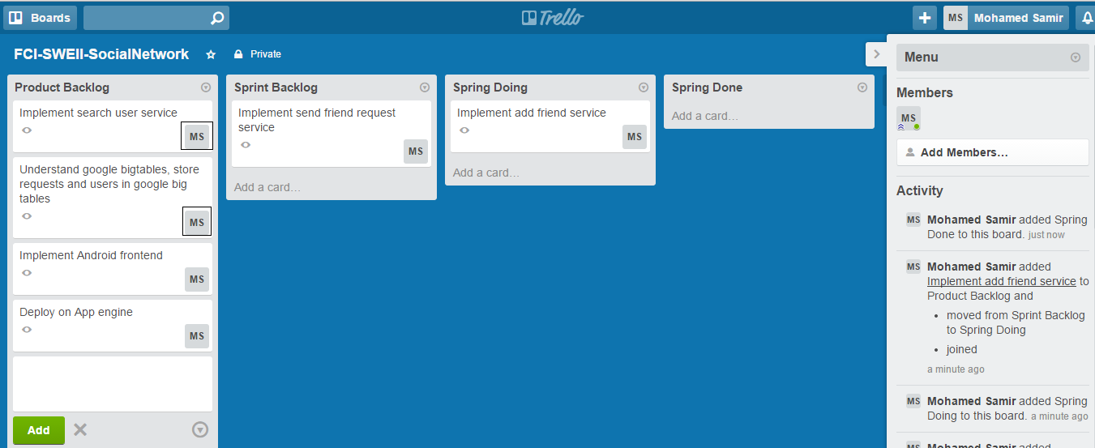

**Note black boxes which state who is responsible for each requirement**